We can order two other types of Gi from Kwon .

Please be aware that only **WHITE** Gi’s are allowed at competitions.

If you need to order, please contact the treasurer of Bushi Judo: sloman@sky.com

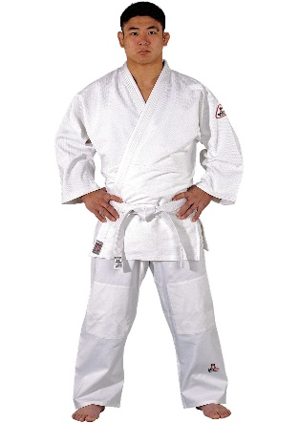**Dojo Line Judo Uniform Tong Il**   
Lightweight model for beginners of all ages. Universal cut bleached white cotton material (425g/m2). Pants feature elastic waistband and knee reinforcements. DANRHO triangle patch on upper left sleeve. Excellent value for the price. Without back seam.   
Comes with a white belt.

|  |  |  |  |  |  |
| --- | --- | --- | --- | --- | --- |
| **Danrho Dojo Line Tong Il - Judo Club Training Uniform** | | | | | |
| **Indicative Measurement** | | A. Jacket Length | B. Sleeve Length | C. Chest Length | D. Inside Leg Length |
| **100** | | 39cm | 41cm | 80cm | 45cm |
| **110** | | 45cm | 47cm | 86cm | 48cm |
| **120** | | 47cm | 47cm | 90cm | 51cm |
| **130** | | 50cm | 47cm | 96cm | 55cm |
| **140** | | 56cm | 54cm | 108cm | 59cm |
| **150** | | 61cm | 60cm | 114cm | 62cm |
| **160** | | 68cm | 65cm | 118cm | 64cm |
| **170** | | 78cm | 69cm | 124cm | 70cm |
| **180** | | 87cm | 70cm | 132cm | 71cm |
| **190** | | 90cm | 73cm | 144cm | 73cm |
|  | |  |  |  |  |
|  | |  |  |  |  |
|  | |  |  |  |  |
| **Back Seam?** | | No | | | |
| **Belt Included?** | | Yes | | | |
| **Collar Width** | | 4.5cm | | | |
| **IJF Recognised?** | | No | | | |
| **Material** | | 100% cotton | | | |
| **Material Weight** | | 425gsm | | | |
| **Other information** | |  | | | |
| **Reinforcements** | | Reinforced collar, padded knees | | | |
| **Shrinkage** | | 5-7cm | | | |
| **Waistband** | | Elastic | | | |
| **Weave** | | Single | | | |
|  |  |
|  |  |
|  |  |

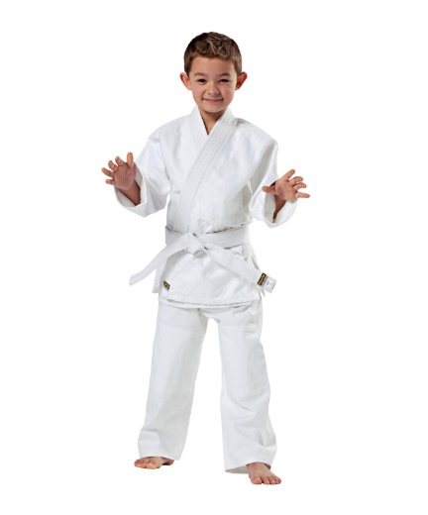**KWON CLUBLINE Judo Uniform Randori**Standard medium-weight model. Made from 100% cotton, bleached white. Multiple-stitched jacket and trousers. Strengthened at shoulders, chest and knees. Includes white belt.

|  |  |
| --- | --- |
|  |  |
|  | |  |  |  |  |  | | --- | --- | --- | --- | --- | | **Danrho Randori Judo Uniform - White** | | | | | | **Indicative Measurement** | A. Jacket Length | B. Sleeve Length | C. Chest Length | D. Inside Leg Length | |  |  |  |  |  | |  |  |  |  |  | | **120** | 57cm | 46cm | 80cm | 45cm | | **130** | 61cm | 51cm | 86cm | 51cm | | **140** | 67cm | 57cm | 96cm | 58cm | | **150** | 76cm | 66cm | 110cm | 65cm | | **160** | 79cm | 70cm | 124cm | 67cm | | **170** | 85cm | 73cm | 128cm | 71cm | | **180** | 90cm | 75cm | 132cm | 77cm | | **190** | 93cm | 86cm | 148cm | 82cm | | **200** | 104cm | 88cm | 152cm | 92cm | |  |  |  |  |  | |  |  |  |  |  | | **Back Seam?** | Seamless back | | | | | **Belt Included?** | No | | | | | **Collar Width** | 4.5cm | | | | | **IJF Recognised?** | No | | | | | **Material** | 100% cotton | | | | | **Material Weight** | 500gsm | | | | | **Other information** | Made to old IJF specifications | | | | | **Reinforcements** | Reinforced knees | | | | | **Shrinkage** | 5-7cm | | | | | **Waistband** | Elastic | | | | | **Weave** | Single | | | | |

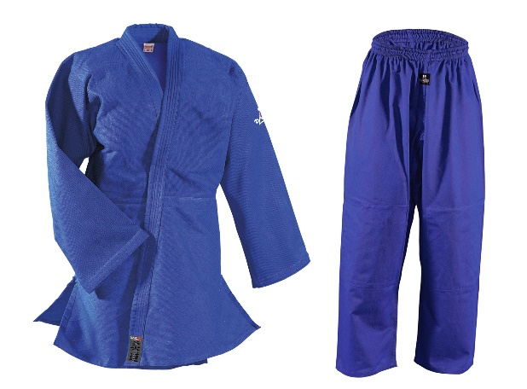**DANHRO Judo Uniform Randori blue**  
Light yet very durable judo uniform for beginners of all ages with reinforcements on knees, chest and shoulders. Fabric is made of 100% cotton (500g/m2) in the typical rice grain structure. Pants come with elastic waistband and white rank belt. Without back seam.

|  |  |
| --- | --- |
|  |  |
|  |  |
|  |  |

|  |  |  |  |
| --- | --- | --- | --- |
|  | **Tong Il** | **RANDORI  (White)** | **RANDORI  (Blue)** |
| **CM** | **PRICE** | **PRICE** | **PRICE** |
| 100 | £11.40 |  |  |
| 110 | £11.40 |  |  |
| 120 | £12.55 | £14.86 | £27.54 |
| 130 | £13.71 | £16.02 | £29.84 |
| 140 | £14.86 | £16.02 | £33.30 |
| 150 | £16.01 | £17.86 | £37.90 |
| 160 | £18.31 | £19.01 | £39.05 |
| 170 | £18.31 | £20.16 | £41.36 |
| 180 | £19.47 | £20.62 | £43.66 |
| 190 | £20.60 | £21.31 | £45.96 |
| 200 |  | £22.47 | £48.27 |